AWS EC2 + AUTO SCALING GROUP
Properly Arranged Step-by-Step Screenshot Guide
Topic: EC2 Launch Template → Auto Scaling Group → SSH → Apache Web Server
Order used: EC2 → Launch Template → AMI / instance settings → Network & Security → Auto Scaling Group → SSH → Apache verification.
Format: Each step has the original screenshot, a short English explanation, and a red CLICK / SELECT arrow where a click is required.

SECTION 1 — AWS EC2 & AUTO SCALING GROUP
Step 1: Aws Ec2 & Auto Scaling Group
What I did: Open the EC2 service to start the AWS compute setup.
Arrow: The red arrow and box mark the main area to click or select in the screenshot.

Step 1 — screenshot reference

SECTION 1 — AWS EC2 & AUTO SCALING GROUP
Step 2: Aws Ec2 & Auto Scaling Group
What I did: Open Launch Templates so the EC2 instance configuration can be created and reused.
Arrow: The red arrow and box mark the main area to click or select in the screenshot.

Step 2 — screenshot reference

SECTION 1 — AWS EC2 & AUTO SCALING GROUP
Step 3: Aws Ec2 & Auto Scaling Group
What I did: Click Create launch template to begin creating the reusable EC2 configuration.
Arrow: The red arrow and box mark the main area to click or select in the screenshot.
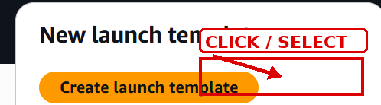
Step 3 — screenshot reference

SECTION 1 — LAUNCH TEMPLATE
Step 4: Launch Template
What I did: Enter the launch template name and description so the configuration can be identified later.
Arrow: The red arrow and box mark the main area to click or select in the screenshot.
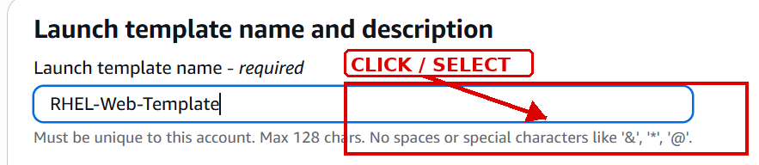
Step 4 — screenshot reference

SECTION 1 — APPLICATION & OS IMAGE
Step 5: Application & Os Image
What I did: Select the required Red Hat Enterprise Linux AMI for the EC2 instance.
Arrow: The red arrow and box mark the main area to click or select in the screenshot.
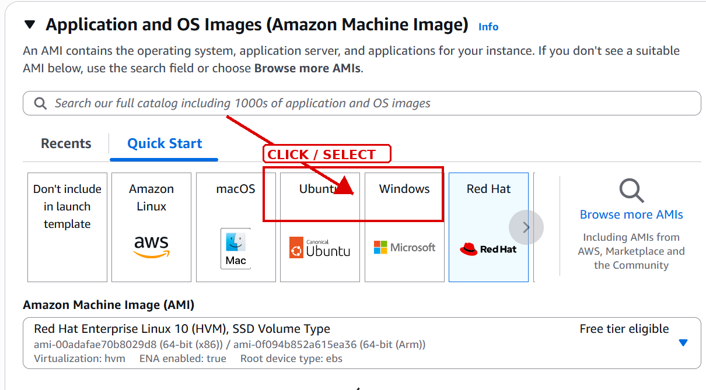
Step 5 — screenshot reference

SECTION 1 — INSTANCE TYPE
Step 6: Instance Type
What I did: Choose the required EC2 instance type for the server.
Arrow: The red arrow and box mark the main area to click or select in the screenshot.
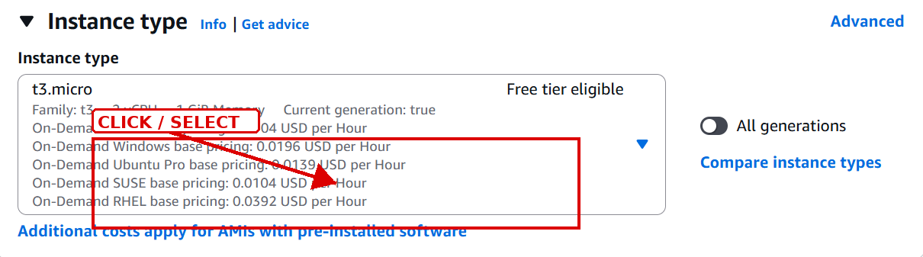
Step 6 — screenshot reference

SECTION 1 — KEY PAIR
Step 7: Key Pair
What I did: Select the key pair that will be used to connect to the EC2 instance.
Arrow: The red arrow and box mark the main area to click or select in the screenshot.
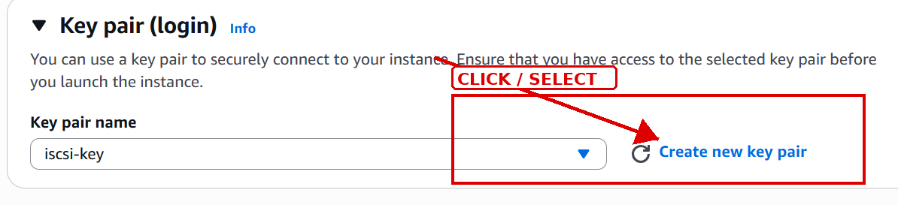
Step 7 — screenshot reference

SECTION 1 — NETWORK & SECURITY
Step 8: Network & Security
What I did: Configure the VPC/network settings and security group for the instance.
Arrow: The red arrow and box mark the main area to click or select in the screenshot.
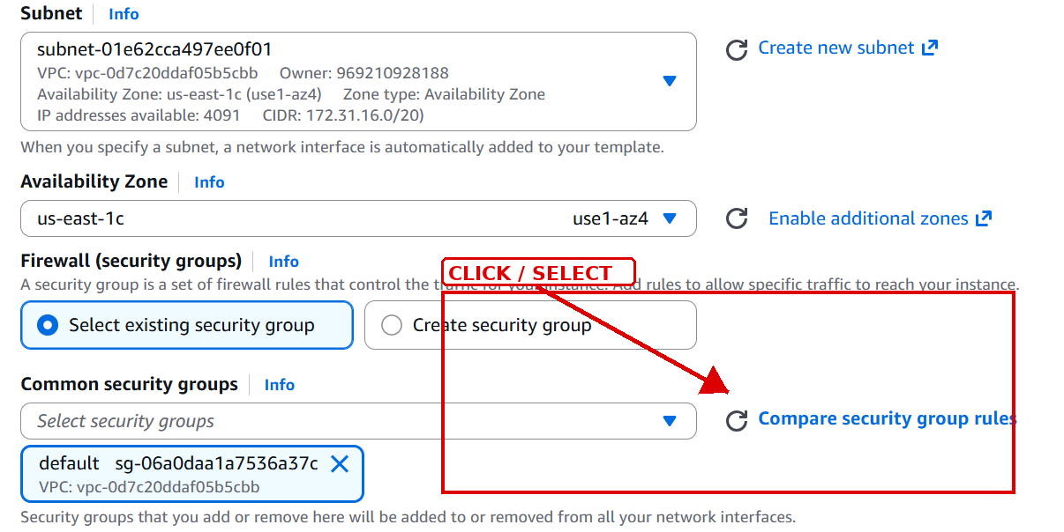
Step 8 — screenshot reference

SECTION 1 — ADVANCED DETAILS
Step 9: Advanced Details
What I did: Open Advanced details to enter the additional instance configuration.
Arrow: The red arrow and box mark the main area to click or select in the screenshot.
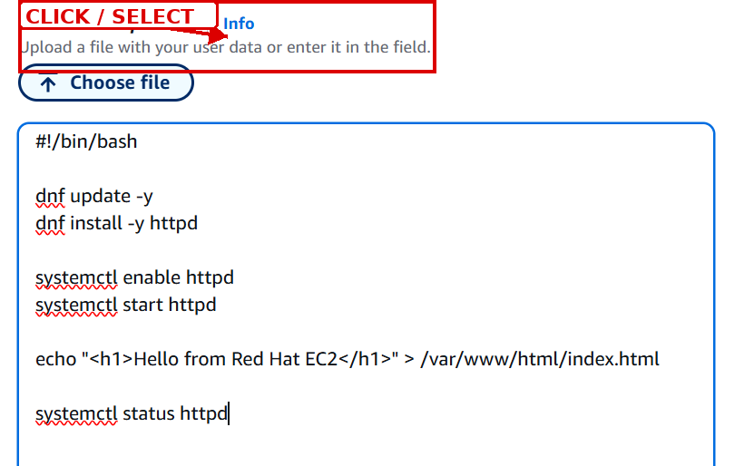
Step 9 — screenshot reference

SECTION 1 — USER DATA
Step 10: User Data
What I did: Enter the required user-data script so the instance can be configured automatically at launch.
Arrow: The red arrow and box mark the main area to click or select in the screenshot.
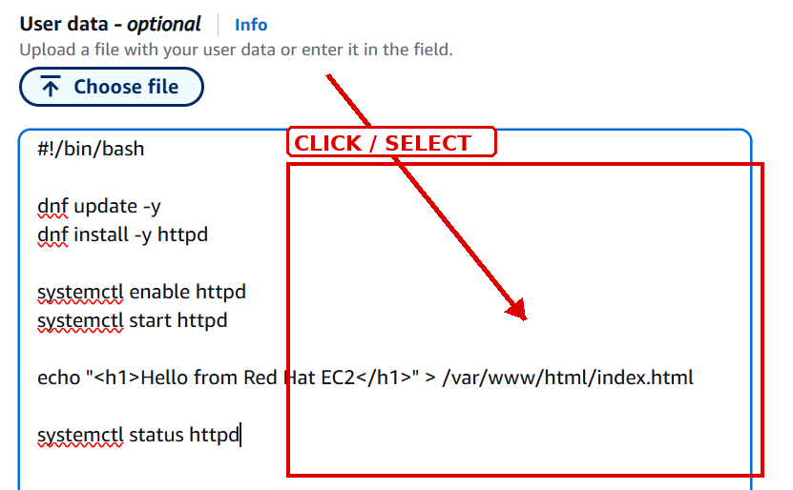
Step 10 — screenshot reference

SECTION 1 — CREATE LAUNCH TEMPLATE
Step 11: Create Launch Template
What I did: Click Create launch template to save the completed EC2 template.
Arrow: The red arrow and box mark the main area to click or select in the screenshot.
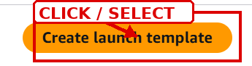
Step 11 — screenshot reference

SECTION 1 — LAUNCH TEMPLATE LIST
Step 12: Launch Template List
What I did: Confirm that the new launch template appears in the list.
Arrow: The red arrow and box mark the main area to click or select in the screenshot.
Step 12 — screenshot reference

SECTION 1 — LAUNCH INSTANCE FROM TEMPLATE
Step 13: Launch Instance From Template
What I did: Open Launch instance from template and select the required launch template.
Arrow: The red arrow and box mark the main area to click or select in the screenshot.
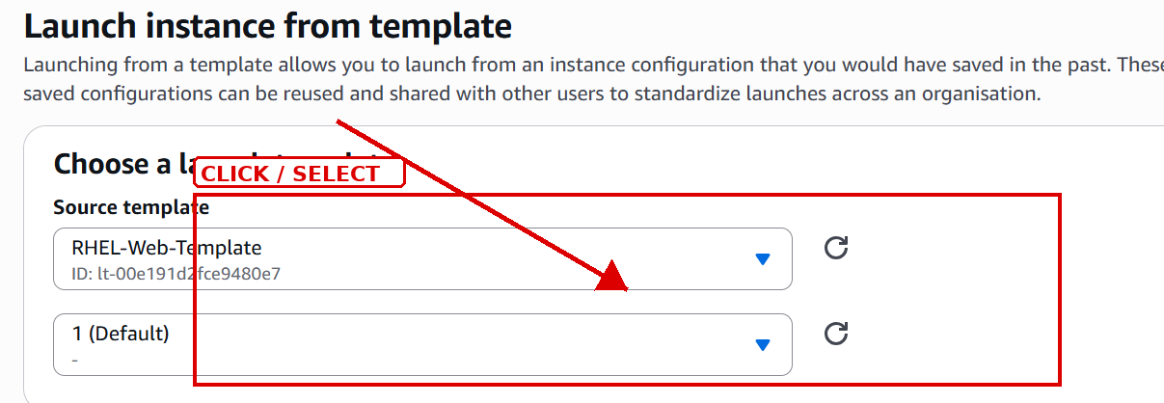
Step 13 — screenshot reference

SECTION 2 — AUTO SCALING GROUP
Step 14: Auto Scaling Group
What I did: Start the Create Auto Scaling group workflow and provide the group name.
Arrow: The red arrow and box mark the main area to click or select in the screenshot.
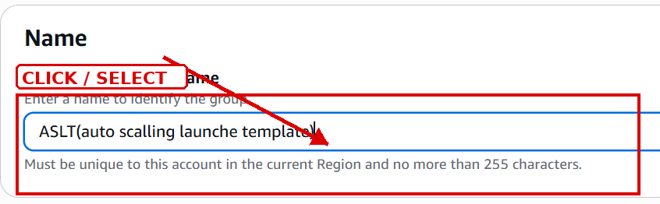
Step 14 — screenshot reference

SECTION 2 — SELECT LAUNCH TEMPLATE
Step 15: Select Launch Template
What I did: Select the launch template and version that the Auto Scaling group should use.
Arrow: The red arrow and box mark the main area to click or select in the screenshot.
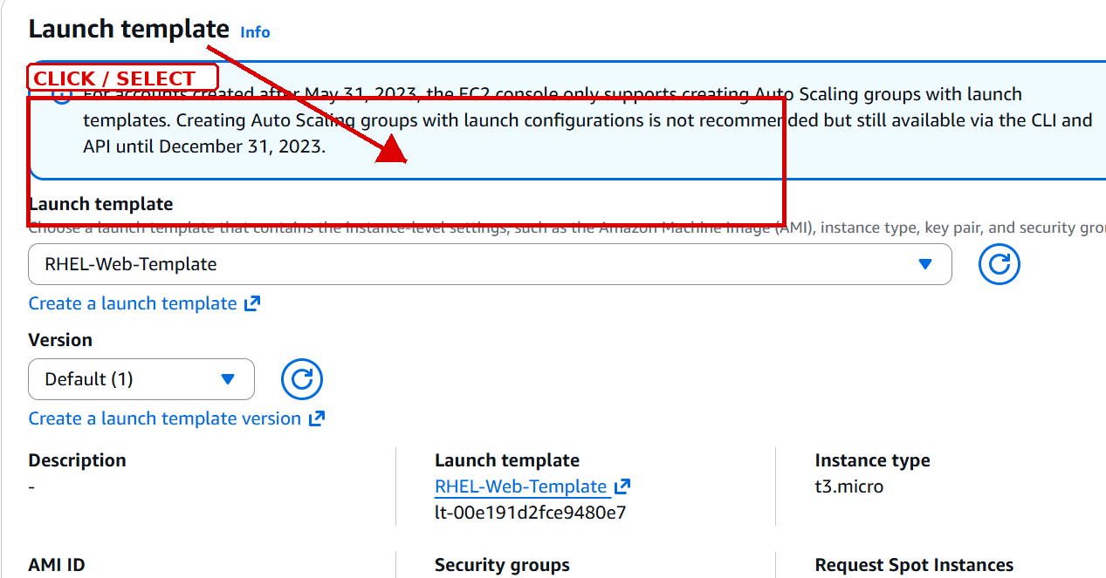
Step 15 — screenshot reference

SECTION 2 — SECURITY GROUP RULES
Step 16: Security Group Rules
What I did: Edit the inbound rules to allow the required network access.
Arrow: The red arrow and box mark the main area to click or select in the screenshot.
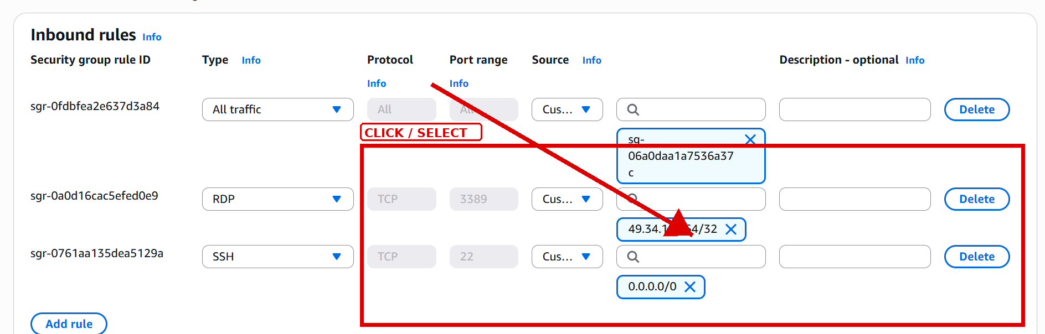
Step 16 — screenshot reference

SECTION 2 — AUTO SCALING — NETWORK
Step 17: Auto Scaling — Network
What I did: Choose the VPC and availability zones/subnets for the Auto Scaling group.
Arrow: The red arrow and box mark the main area to click or select in the screenshot.
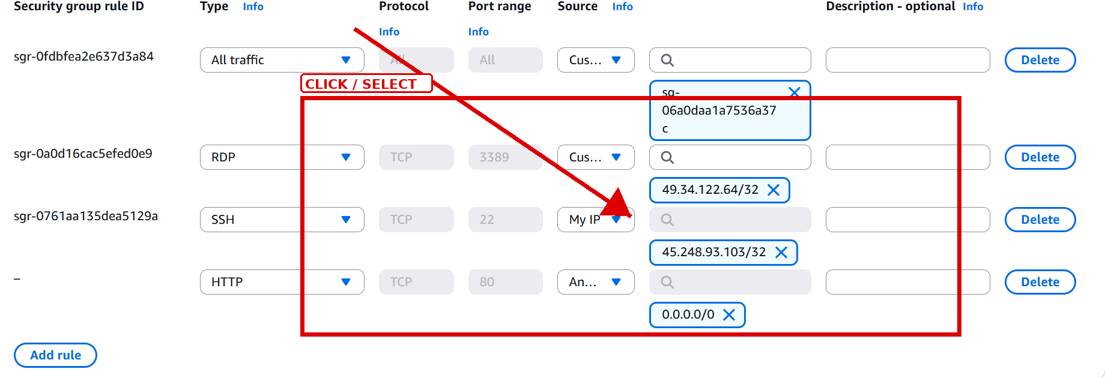
Step 17 — screenshot reference

SECTION 2 — AUTO SCALING — SCALING
Step 18: Auto Scaling — Scaling
What I did: Set the desired capacity and scaling limits for the group.
Arrow: The red arrow and box mark the main area to click or select in the screenshot.
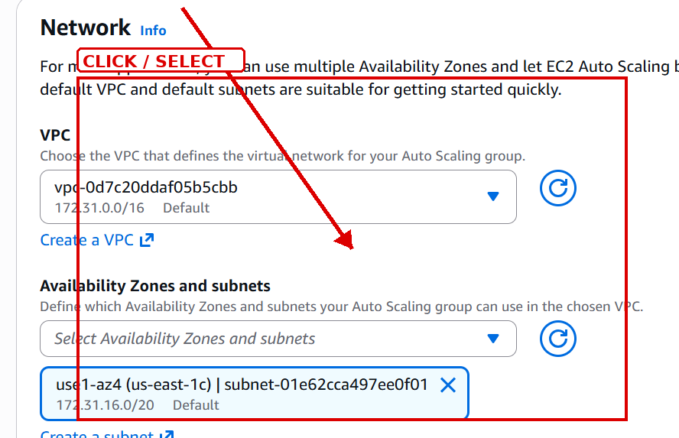
Step 18 — screenshot reference

SECTION 2 — AUTO SCALING — REVIEW
Step 19: Auto Scaling — Review
What I did: Review the Auto Scaling group settings before creating the group.
Arrow: The red arrow and box mark the main area to click or select in the screenshot.
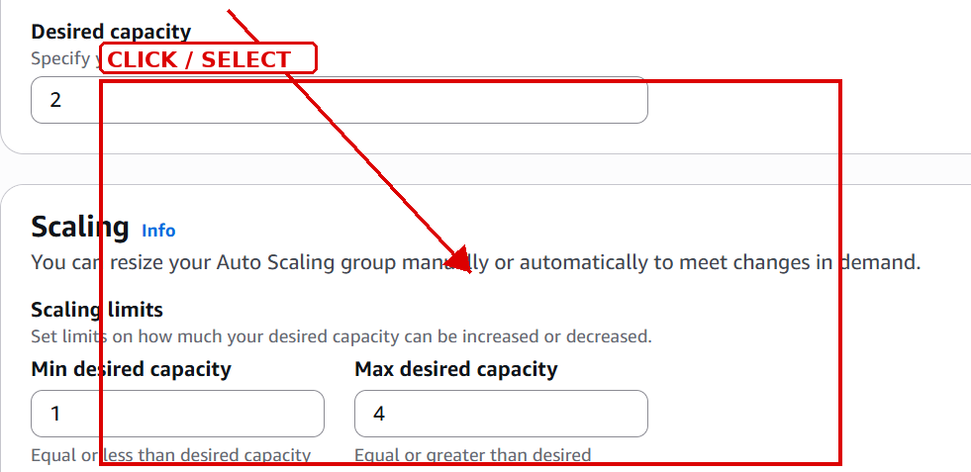
Step 19 — screenshot reference

SECTION 2 — CREATE AUTO SCALING GROUP
Step 20: Create Auto Scaling Group
What I did: Click Create Auto Scaling group to finish the Auto Scaling configuration.
Arrow: The red arrow and box mark the main area to click or select in the screenshot.

Step 20 — screenshot reference

SECTION 2 — EC2 CONNECT / PUBLIC DNS
Step 21: Ec2 Connect / Public Dns
What I did: Use the instance connection information, including the public DNS/IP, to connect to the server.
Arrow: The red arrow and box mark the main area to click or select in the screenshot.
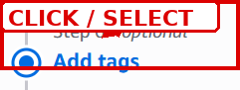
Step 21 — screenshot reference

SECTION 3 — SSH CONNECTION
Step 22: Ssh Connection
What I did: Run the SSH command with the key file and EC2 user to connect to the Red Hat server.
Arrow: No click is required here; this screenshot shows the command or result/output.
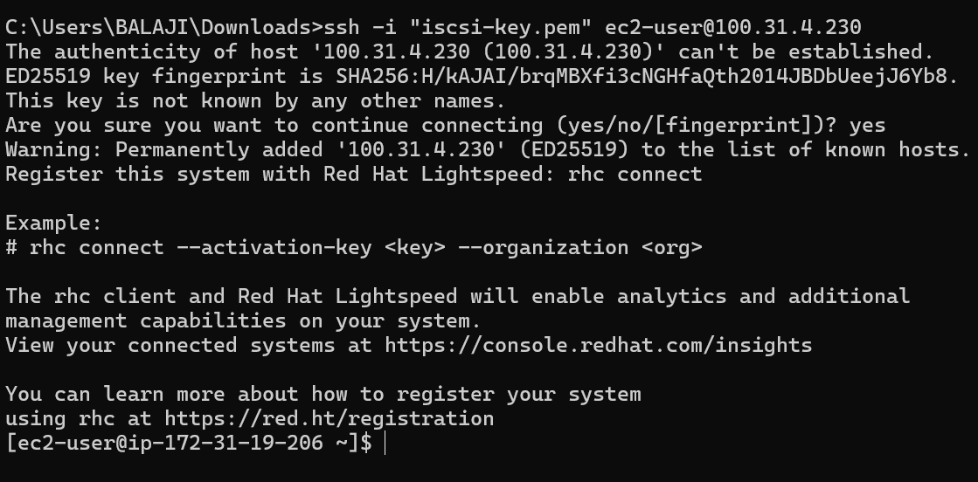
Step 22 — screenshot reference

SECTION 3 — TEST PORT 22
Step 23: Test Port 22
What I did: Test TCP connectivity to port 22 and confirm that the SSH connection path is reachable.
Arrow: No click is required here; this screenshot shows the command or result/output.
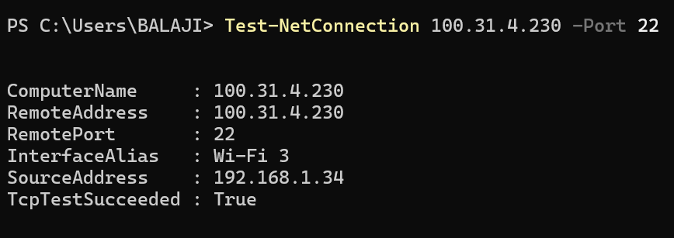
Step 23 — screenshot reference

SECTION 3 — APACHE SERVICE
Step 24: Apache Service
What I did: Check the Apache HTTP Server service and confirm that it is active and running.
Arrow: No click is required here; this screenshot shows the command or result/output.
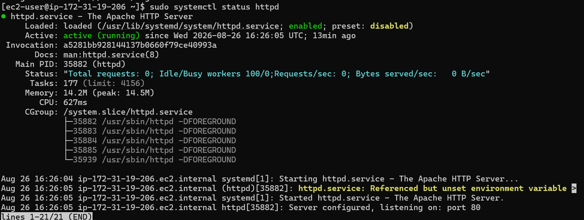
Step 24 — screenshot reference

SECTION 3 — WEB SERVER TEST
Step 25: Web Server Test
What I did: Use curl against the server address and confirm that the Red Hat EC2 web page responds.
Arrow: No click is required here; this screenshot shows the command or result/output.
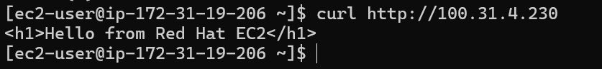
Step 25 — screenshot reference

QUICK REFERENCE
Use the steps in order. The red arrows show where to click/select; terminal screenshots are marked as command/result steps rather than click steps.

